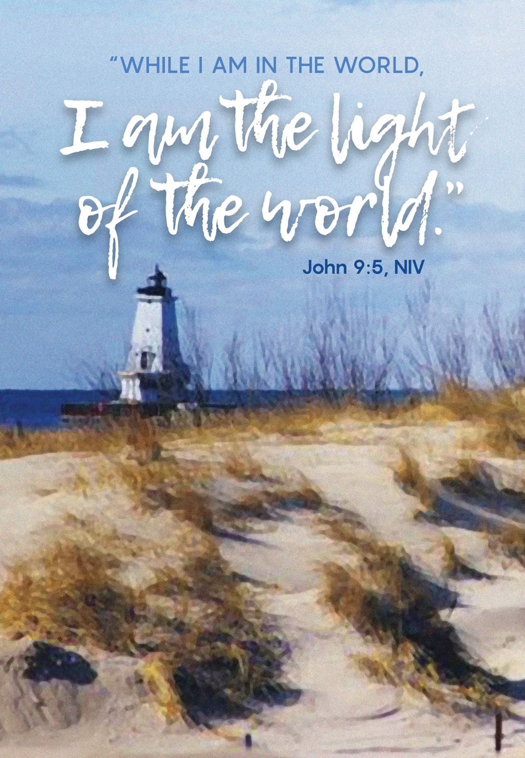

Fourth Sunday in Lent
Sunday, March 22, 2020

Fourth Sunday in Lent
Sunday, March 22, 2020
9:00 AM

Baptism is sometimes called enlightenment.
The gospel for this Sunday is the story of
the man born blind healed by Christ.
“I was blind, now I see,” declares the man.
In baptism God opens our eyes to see the truth of who we are:
God’s beloved children.
As David was anointed king of Israel,
in baptism God anoints our head with oil,
and calls us to bear witness to the light of Christ in our daily lives.

WELCOME / ANNOUNCEMENTS

“Looking Toward the Cross”

PRELUDE
Smith

CONFESSION AND FORGIVENESS

Blessed be the holy Trinity, ☩ one God,
who is present, who gives life,
who calls into existence the things that do not exist.
Amen.

If you were to keep watch over sins, O Lord, who could stand?
Yet with you is forgiveness, and so we confess.

Silence is kept for reflection.

Gracious God,
have mercy on us.
We confess that we have turned away from you,
knowingly and unknowingly.
We have wandered from your resurrection life.
We have strayed from your love for all people.
Turn us back to you, O God.
Give us new hearts and right spirits,
that we may find what is pleasing to you
and dwell in your house forever. Amen.

Receive good news: God turns to you in love.
“I will put my spirit in you, and you shall live,” says our God.
All your sin is forgiven in the name of ☩ Jesus Christ,
who is the free and abounding gift of God’s grace for you.
Amen.

WORD

FIRST READING 1 Samuel 16:1-13

¹The Lord said to Samuel, “How long will you grieve over Saul? I have rejected him from being king over Israel. Fill your horn with oil and set out; I will send you to Jesse the Bethlehemite, for I have provided for myself a king among his sons.” ²Samuel said, “How can I go? If Saul hears of it, he will kill me.” And the Lord said, “Take a heifer with you, and say, ‘I have come to sacrifice to the Lord.’ ³Invite Jesse to the sacrifice, and I will show you what you shall do; and you shall anoint for me the one whom I name to you.” ⁴Samuel did what the Lord commanded, and came to Bethlehem. The elders of the city came to meet him trembling, and said, “Do you come peaceably?” ⁵He said, “Peaceably; I have come to sacrifice to the Lord; sanctify yourselves and come with me to the sacrifice.” And he sanctified Jesse and his sons and invited them to the sacrifice.
⁶When they came, he looked on Eliab and thought, “Surely the Lord’s anointed is now before the Lord.” ⁷But the Lord said to Samuel, “Do not look on his appearance or on the height of his stature, because I have rejected him; for the Lord does not see as mortals see; they look on the outward appearance, but the Lord looks on the heart.” ⁸Then Jesse called Abinadab, and made him pass before Samuel. He said, “Neither has the Lord chosen this one.” ⁹Then Jesse made Shammah pass by. And he said, “Neither has the Lord chosen this one.” ¹⁰Jesse made seven of his sons pass before Samuel, and Samuel said to Jesse, “The Lord has not chosen any of these.” ¹¹Samuel said to Jesse, “Are all your sons here?” And he said, “There remains yet the youngest, but he is keeping the sheep.” And Samuel said to Jesse, “Send and bring him; for we will not sit down until he comes here.” ¹²He sent and brought him in. Now he was ruddy, and had beautiful eyes, and was handsome. The Lord said, “Rise and anoint him; for this is the one.” ¹³Then Samuel took the horn of oil, and anointed him in the presence of his brothers; and the spirit of the Lord came mightily upon David from that day forward. Samuel then set out and went to Ramah.

L: Word of God. Word of Life.
Thanks be to God!

PSALM Psalm 23

¹The Lord is my shepherd;
I shall not be in want.
²The Lord makes me lie down in green pastures
and leads me beside still waters.
³You restore my soul, O Lord,
and guide me along right pathways for your name’s sake.
⁴Though I walk through the valley of the shadow of death, I shall fear no evil;
for you are with me; your rod and your staff, they comfort me.
⁵You prepare a table before me in the presence of my enemies;
you anoint my head with oil, and my cup is running over.
⁶Surely goodness and mercy shall follow me all the days of my life,
and I will dwell in the house of the Lord forever.

GOSPEL John 9:1-11

The Holy Gospel according to John, the 9^{h} chapter.
Glory to you, O Lord.

¹As [Jesus] walked along, he saw a man blind from birth. ²His disciples asked him, “Rabbi, who sinned, this man or his parents, that he was born blind?” ³Jesus answered, “Neither this man nor his parents sinned; he was born blind so that God’s works might be revealed in him. ⁴We must work the works of him who sent me while it is day; night is coming when no one can work. ⁵As long as I am in the world, I am the light of the world.” ⁶When he had said this, he spat on the ground and made mud with the saliva and spread the mud on the man’s eyes, ⁷saying to him, “Go, wash in the pool of Siloam” (which means Sent). Then he went and washed and came back able to see. ⁸The neighbors and those who had seen him before as a beggar began to ask, “Is this not the man who used to sit and beg?” ⁹Some were saying, “It is he.” Others were saying, “No, but it is someone like him.” He kept saying, “I am the man.” ¹⁰But they kept asking him, “Then how were your eyes opened?” ¹¹He answered, “The man called Jesus made mud, spread it on my eyes, and said to me, ‘Go to Siloam and wash.’ Then I went and washed and received my sight.”

P: The Gospel of the Lord.
Praise to you, O Christ.
MUSIC MEDITATION

“Praise the One Who Breaks the Silence”
Wyeth
SERMON
“The Light of the World in the Darkest Valley”
”
Pastor Aaron

PRAYERS OF INTERSESSION

Turning our hearts to God who is gracious and merciful,
we pray for the church, the world, and all who are in need.

A brief silence.

God of insight, open our hearts to the testimony of your Word. Give us faith to see you in this dark valley and lead us each step of the way. Inspire us by the witness of saints who have gone before us, like the 18th-century theologian, Jonathan Edwards, who we commemorate today, whose wisdom and sacrifice encouraged the science of vaccination.

Hear us, O God.
Your mercy is great.

God of creation, send your Spirit and strengthen the life-giving bonds among us however great the distance is between us. Teach us new ways to live out your covenantal love. Meet our stewarding care of the earth with your nourishing resources and provide abundantly for all in need.

Hear us, O God.
Your mercy is great.

God of peace, bring hope and direction to all people. Anoint leaders with a spirit of wisdom to govern prudently and courage to act compassionately. We pray for China, Italy, Iran, Spain, France, Germany, South Korea, the United States, and all nations affected by the coronavirus. Shield the vulnerable. Comfort the dying and those who have lost loved ones. Enable us to endure this hour of trial.

Hear us, O God.
Your mercy is great.

God of healing, you care for our needs even before we ask. Come quickly to the aid of those who seek prayer this day, especially Jean Baughman, Ray Guillard, Rachel Houser, Brian Helman, David Hoffman, Art Horne, Sam Keebaugh, Christine Lindeman, Heidi Lucas, Gloria McCauley, Ron Portner, Larry Royce, Mary Royce, Rusty Tarner, Sherry Salmon, Terry Shaak, Tracey Thrush, and Ray Wagner. Accomplish healing through the work of doctors, nurses, physical therapists, nutritionists, and all who make it their vocation to care for others. Protect them as they carry out their work.

Hear us, O God.
Your mercy is great.

Continues on next page.
God of rebirth, you have created and sustained this community of faith. Keep us steadfast in your Word and renew our sense of fellowship. We pray especially for Adam Stambaugh; J. Ronald Stambaugh; Andrew Stanish; Molly Stanish; Scott & Julie Stanish; Nancy Stehle; Ronald Stepler; Diane Sterner; Florence Sterner; and Hazel Strait.

Hear us, O God.
Your mercy is great.

God of the living, you call out to those who are asleep and awaken them to new life. We give thanks for all who now enjoy uninterrupted communion with you. Join us together with them as your children in this world and the next.

Hear us, O God.
Your mercy is great.

According to your steadfast love, O God, hear these and all our prayers as we commend them
to you; through Christ our Lord.

Amen.

The Lord’s Prayer

Gathered with all who call on his name, let us pray as Jesus taught us:

Our Father, who art in heaven,
hallowed be thy name,
thy kingdom come,
thy will be done,
on earth as it is in heaven.
Give us this day our daily bread;
and forgive us our trespasses,
as we forgive those
who trespass against us;
and lead us not into temptation,
but deliver us from evil.
For thine is the kingdom,
and the power, and the glory,
forever and ever. Amen

SENDING

THE BENEDICTION

Now is the acceptable time.
Now is the day of salvation.
Holy God,
speaking, spoken, and inspiring,
☩ bless you, unbind you,
and send you in love and in peace.
Amen.

DISMISSAL

Go in peace. Share the good news.
Thanks be to God.
POSTLUDE
“If You But Trust in God to Guide You”
Neumark
Liturgy and Music used by permission of Augsburg Fortress license #13649-S and CCLI License # 2469818

The bulletins are given to the Glory of God and
in honor of Susan McDonald / Ettenhofer’s Birthday,
by Joyce McDonald & family.

STEWARDSHIP SNIPPET

John 9:38 - He said, “Lord, I believe.”
And he worshiped him.
Stewarding your soul may mean responding
as the blind man in this week’s gospel lesson.
Simply open your eyes to the experience
of Jesus and his amazing love and mercy.
Budgeted amount needed: $8,072.12 3/15/2020 Offering: $4,281.00
Thank You!

